Name: Igcalinos, Christian Dirk Axel S.

Y&S: IT26B

Cascade:

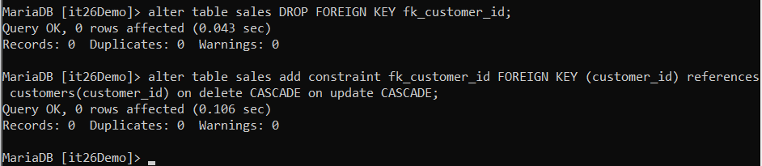

Delete:



Update:



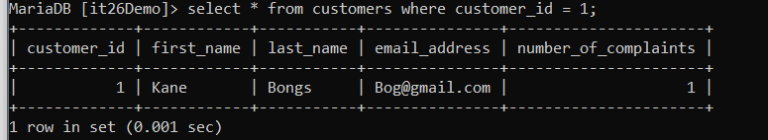

Select:

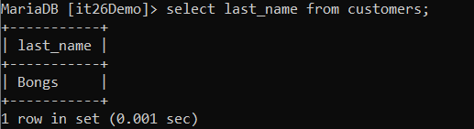

Insert (***Insert Into*** in this case):

